诚信应考,考试作弊将带来严重后果！
_____________ ________
…

姓名 学号
学院 专业 座位号
( 密 封 线 内 不 答 题 )
……………………………………………………密………………………………………………封………………………………………线……………………………………线………………………………………

华南理工大学期末考试
《 Data Structures and Algorithms 》试卷B
注意事项：1. 考前请将密封线内填写清楚；
2. 所有答案请直接答在试卷上；
3．考试形式：闭卷；
4. 本试卷共十大题，满分100分，考试时间120分钟。
题 号 | 一 | 二 | 三 | 四 | 五 | 六 | 七 | 八 | 九 | 十 | 总分
得 分
评卷人
1. Select the correct choice. (20 scores, each 2 scores)
(1) Pick the growth rate that corresponds to the most inefficient algorithm as n gets large: ( )
(A) 2n³ (B) 2n²logn (C) n! (D) 2^{n}
(2) An algorithm must be or do all of the following EXCEPT: ( )
(A) Partially correct (B) Ambiguous (C) Can stop (D) Concrete steps
(3) If a data element requires 8 bytes and a pointer requires 2 bytes, then a linked list representation will be more space efficient than a standard array representation when the fraction of non-null elements is less than about: ( )
(A) 4/5 (B) 1/4 (C) 4/7 (D) 3/4
(4) An algorithm must be or do all of the following EXCEPT: ( )
(A) Partially correct (B) Ambiguous (C) Terminate (D) Concrete steps
(5) Which statement is not correct among the following four: ( )
- The Quick-sort is an unstable sorting algorithm.
- The number of empty sub-trees in a non-empty full binary tree is one more than the number of nodes in the tree.
- The worst case for my algorithm is n becoming larger and larger because that is the slowest.
- A cluster is the smallest unit of allocation for a file, so all files occupy a multiple of the cluster size.
(6) Which algorithm is used to generate runs in classic external sorting? ( )
(A) Replacement selection (B) Bubble sort
(C ) Insertion sort (D) Quick-sort

(7) Which of the following is a true statement: ( )
(A) A general tree can be transferred to a binary tree with the root having both left child and right child.
(B) In a BST, the node can be enumerated sorted by a preorder traversal to the BST.
(C) In a BST, the left child of any node is less than the right child, but in a heap, the left child of any node could be less than or greater than the right child.
(D) A heap must be full binary tree.
(8) The golden rule of a disk-based program design is to: ( )
(A) Improve the basic operations. (B) Minimize the number of disk accesses.
(C) Eliminate the recursive calls. (D) Reduce main memory use.

(9) Which of the following is a true statement: ( )
(A) A general tree can be transferred to a binary tree with the root having both left child and right child.
(B) In a BST, the node can be enumerated sorted by a preorder traversal to the BST.
(C) In a BST, the left child of any node is less than the right child, but in a heap, the left child of any node could be less than or greater than the right child.
(D) A heap must be full binary tree.
(10) The golden rule of a disk-based program design is to: ( )
(A) Improve the basic I/O operations. (B) Minimize the number of disk accesses.
(C) Eliminate the recursive calls. (D) Reduce main memory use.

2. Determine Θ for the following code fragments in the average case. Assume that all variables are of type int. (6 scores)
(1) sum=0;
for (i=0; i<5; i++)
for (j=0; j<n; j++)
sum++; solution : Θ

(2) sum = 0;
for(i=1;i<=n;i++)
for(j=n;j>=i;j--)
sum++; solution : Θ

(3) sum=0;
if (EVEN(n))
for (i=0; i<n; i++)
sum++;
else
sum=sum+n; solution : Θ

3. (16 scores)
A common problem for compilers and text editors is to determine if the parentheses (or other brackets) in a string are balanced and properly nested. For example, the string “((())())()” contains properly nested pairs of parentheses, but the string “)()(” does not, and the string “())” does not contain properly matching parentheses.
(a) Give an algorithm that returns true if a string contains properly nested and balanced parentheses, and false otherwise. Use a stack to keep track of the number of left parentheses seen so far. Hint: At no time while scanning a legal string from left to right will you have encountered more right parentheses than left parentheses. (8 scores)
(b) Give an algorithm that returns the position in the string of the first offending parenthesis if the string is not properly nested and balanced. That is, if an excess right parenthesis is found, return its position; if there are too many left parentheses, return the position of the first excess left parenthesis. Return -1 if the string is properly balanced and nested. Use a stack to keep track of the number and positions of left parentheses seen so far. (8 scores)

4. Assume that a given binary tree stores integer values in its nodes. Write a recursive function that sums the values of all nodes in the tree. (6 scores)

5. Trace by hand the execution of creation a binary search tree with the input sequence as : {46，25，78，62，12，37，70，29} which is empty tree initially. (6 scores)

6. Show the max-heap that results from running buildHeap on the following values stored in an array:
10 5 12 3 2 1 8 7 9 4
(8 scores)

7. Assume a disk drive is configured as follows. The total storage is approximately 1.35G divided among 15 surfaces. Each surface has 612 tracks; there are 144 sectors/track, 1024 byte/sector, and 16 sectors/cluster. The interleaving factor is four. The disk turns at 7200rmp (8.33 ms/r). The track-to-track seek time is 20 ms, and the average seek time is 80 ms. Now how long does it take to read all of the data in a 360 KB file on the disk? Assume that the file’s clusters are spread randomly across the disk. A seek must be performed each time the I/O reader moves to a new track. Show your calculations. (The process of your solution is required!!!) (9 scores)

8. Using closed hashing, with double hashing to resolve collisions, insert the following keys into a hash table of eleven slots (the slots are numbered 0 through 10). The hash functions to be used are H1 and H2, defined below. You should show the hash table after all eight keys have been inserted. Be sure to indicate how you are using H1 and H2 to do the hashing. ( The process of your solution is required!!!)
H1(k) = 3k mod 11 H2(k) = 7k mod 10+1
Keys: 22, 41, 53, 46, 30, 13, 1, 67. (9 scores)

9. Show the result of inserting the value 55 into the B-tree. (10 scores)
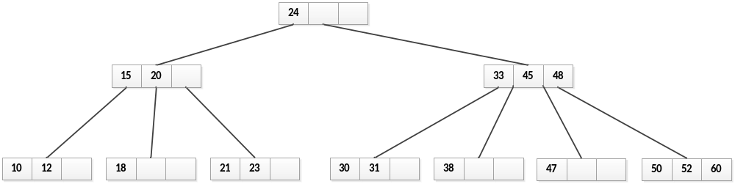

10. (10 scores)
1) Show the DFS tree for the graph, starting at Vertex 1.
2) List the order in which the edges of the graph are visited when running Kruskal’s MST algorithm.
